Study on Three Different Prunus mume Cultivar Groups In Vitro Rapid Propagation
Ran-Xin Li, Cheng-Ke Li，Ying-Min Lu*
- College of Landscape Architecture, Beijing Forestry University, Beijing 100083, China
Ran-Xin Li
Email:694910994@qq.com
Ying-Min Lu
Email:luyingmin@bjfu.edu.cn
Abstract
Three Prunus mume cultivars, belonging to three different groups, including ‘Wu Yuyu’ (Zhusha cultivar group), ‘Xiao Yudie’ (Yudie cultivar group) and ‘Xiao Lv’e’ (Lv’e cultivar group) were chosen as materials to be micro-propagated in vitro. Different explants types, disinfection time and hormone species and concentrations were used as factors, which influenced the culture of Prunus mume budded stems, to optimize the initiation culture mechanism of Prunus mume budded stems. Results show that optimal explants of three Prunus mume groups are stemmed from non-tender healthy part in the upper twigs. The best disinfection time is 10min immersed in Hgcl₂ solution. The optimum medium for the shoot section of ‘Xiao Yudie’ to grow in vitro is the WB medium supplemented with 0.2mg/L NAA and 0.5mg/L BA.The optimum proliferation medium for ‘Xiao Lv’e’ is improved WB medium supplemented with 0.1mg/LNAA and 0.5mg/LBA, while the optimum proliferation medium for ‘Wu Yuyu’ is supplemented with 0.1 mg/ L NAA and 0.1 mg/L KT. On the basis of subculture, medium, hormone type and concentration were studied. The results show that the most suitable medium for multiplication of Zhusha cultivar group is WPM＋1.0mg/L BA＋1.0mg/L 2,4-D＋0.2mg/L TDZ＋100mg/L AHC,Yudie cultivar group is 1/2MS＋1.0mg/L BA＋1.0mg/L 2,4-D＋0.5mg/L NAA＋0.2mg/L TDZ＋100mg/L AHC,and Lv’e cultivar group is WPM＋1.0mg/L BA＋1.0mg/L 2,4-D＋0.2mg/L TDZ＋100mg/L AHC.
Keywords Prunus mume - Stem with axillary bud - In vitro rapid propagation.
INTRODUCTION
Prunus mume, Rosaceae, Prunus, is a kind of deciduous tree which is endemic to China.
It’s one of the Chinese traditional ornamental flowers of the top 10, playing a decisive role in China’s garden and flower culture (Chen 2010). By now , the main breeding methods of Prunus mume are always cutting and grafting, which can maintain desirable qualities , however coefficient of reproduction (e.g., Chai et al.1988; Fu et al. 1991; Fu et al. 1995; Jiang et al. 2004; Liu et al. 1999).Tissue culture can solve the follow-up difficulty in question which is a reliable and fast way (Cao et al. 2005 ) .In vitro propagation of plum is essential to the foundation of its genetic transformation system. The establishment of Asexual System and Test tube not only can provide the important test materials for the next step of transgenic breeding, but also a part of the next step of callus induction and differentiation of seedling (Cao and Lv 2004). At present, to establish rapid propagation system by the tissue culture of stem segments has always been an important way of research and production of seedlings. But in vitro rapid propagation system of Prunus mume, the progress is rather little, and only a few varieties have realized the goal technically (e.g., Harada et al.1996; Olaya et al. 2000; Quoirin et al. 1977).
There are more than 300 varieties of Prunus mume. At present, the tissue culture of ‘Wu Yuyu’ (Zhusha cultivar group), ‘Xiao Yudie’ (Yudie cultivar group) and ‘Xiao Lv’e’ (Lv’e cultivar group) has not been reported. So, we conduct a research of this three cultivar group, in order to provide a support theoretically and technically for the rapid propagation and further genetic breeding of Prunus mume.
Materials and methods
Plant material and explant preparation
The explants, collected from Meiyuan of Jiufeng National Forest Park are ‘Wu Yuyu’ (Zhusha cultivar group), ‘Xiao Yudie’ (Yudie cultivar group) and ‘Xiao Lv’e’ (Lv’e cultivar group).
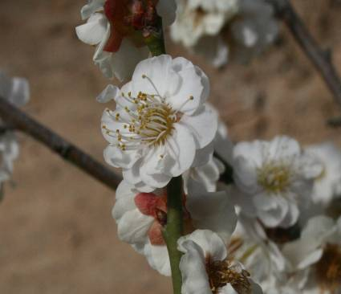 | 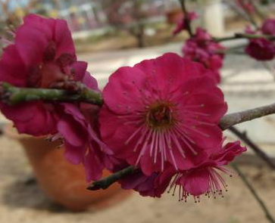 | 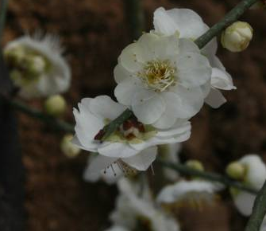
Fig1. ‘Xiao Yudie’ Fig2. ‘Wu Yuyu’ Fig3. ‘Xiao Lv’e’
The experiment was conducted in the tissue culture laboratory in October. The materials were collected from the 1-2 years old branches of stock plants. The trees we have chosen are fairly strong without diseases and insects, shoots, the experimental materials, are in the same size (length and width), stemmed from peripheral branches which are distributed in the Crown Center.
Explants disinfection, Medium and culture conditions
Cutting away the leaves and petioles from the stem(in order to protect the bud ,we need to retain petiole about 0.1-0.2cm),then cut the treated stem into several parts each of which are about 1-2cm .Next, we soak the treated stem in the detergent about 30min,then rinse them 1h. Under aseptic conditions, the material will be immersed in 75% alcohol for 30s, and then disinfected by 0.1%Hgcl₂, the treatment are under 5、10、15min , then rinsed 5 times by sterile water. Finally, we vaccinate the treated material into medium. For each 20 stems, repeat 3 times.
We choose WB medium as basic medium (Fu.1993) , sucrose 30 g/L and agar 6.5 g/L are added into the medium. The pH of medium is 6.0.
The container of the experiment is 100 mL culture flask, 50 mL medium per flask. Medium was autoclaved at 118℃ for 20 min.. The cultures were incubated at 24±2°C in light with 16-h photoperiod supplied by white fluorescent tube lights. We observe the growth of materials once a week, record explants pollution and growth conditions.
Callus proliferation
Cutting the test tube leaves of primary culture from the base of the petiole, then inoculate them into secondary culture after cutting the leaves into 0.5cm×0.5cm pieces. After the formation of callus, we can get new plant from transformed callus by regulating hormone. All the materials are placed at 23±2 ℃ for induction.
Hormone: 6-BA (1.0mg/L), 2, 4-D (1.0mg/L), NAA (0, 0.5, 1.0mg/L), TDZ (0, 0.2, 0.4mg/L), AHC (0,100,200mg/L).
Root induction
Inoculate the proliferative seedlings into the rooting medium, which is WPM＋0.3mg/L NAA.
Statistical analysis
All experiments were performed with a minimum of twenty explants per treatment and each experiment was repeated three times. The data were collected after 4 weeks. For explants disinfection and Medium and culture conditions, the mean (%) of explants germination were measured. In Callus proliferation, mean multiplication coefficient, average bud length and average bud height were recorded. The data were analyzed statistically using IBM SPSS statistics 19(SPSS Inc., Chicago, USA) and the mean values were expressed as mean±SE. The significance of differences among means was carried out at 5% probability level using Duncan’s Multiple Range Test (DMRT).
Germination rate＝(Bud number/Survival number)×100%.
Multiplication coefficient＝Buds which can be transferred out / Inoculated buds×100%
Results and analysis
Explants disinfection, Medium and culture conditions
There are certain differences between the testing species, cultivar groups and varieties. The germination rate of ‘Wu Yuyu’ is 69.81%, ‘Xiao Yudie’ is 85.71% , while ‘Xiao Lv’e’ is 80.39% . Results show distinctness between varieties is: Yudie cultivar group＞Lv’e cultivar group＞Zhusha cultivar group. It can be concluded from the experiment that genotype has an important influence on the tissue culture of Prunus mume.
Cut materials from upper，central and lower part of the stem , inoculate them into culture medium WB＋KT2.0mg/L＋NAA0.05mg/L.In general , the central part received a higher germination rate.
As we can see from table 1, the lower parts have a low germination rate and grow slowly. The central parts of ‘Xiao Yudie’ and ‘Xiao Lv’e’ reach the highest germination rate(85.19% and 59.13%), but grow gently; while the upper parts of ‘Wu Yuyu’ achieves a higher germin- ation rate , with a rapid growth. In these three cultivars, the highest germination rate group achieves in Yudie cultivar group of 85.19%. The germination rate difference between the central and the lower parts of Zhusha cultivar group is not significant. From this it follows that the most suitable material for Yudie and Lv’e cultivar group is the central part of stem, while for Zhusha cultivar gro- up is the upper part.
Table1 The effects on germination rate of the different material parts which collected from branches
Variety | Material parts | Germination rate (%)
‘Wu Yuyu’ -Zhusha cultivar group | Upper | 58.58a
‘Wu Yuyu’ -Zhusha cultivar group | Central | 51.11b
‘Wu Yuyu’ -Zhusha cultivar group | Lower | 45.95b
‘Xiao Yudie’ -Yudie cultivar group | Upper | 76.00b
‘Xiao Yudie’ -Yudie cultivar group | Central | 85.19a
‘Xiao Yudie’ -Yudie cultivar group | Lower | 57.89c
‘Xiao Lv’e’ -Lv’e cultivar group | Upper | 45.58b
‘Xiao Lv’e’ -Lv’e cultivar group | Central | 59.13a
‘Xiao Lv’e’ -Lv’e cultivar group | Lower | 34.29c

Because of contamination of the material and disoperation, the pollution always exists in vitro culture, so the inoculating material must go through strict sterilization (e.g., Chen and sun.2007; Chen .2003) . In order to know the most suitable time of explants disinfection In this experiment, we set three disinfection time gradients by 0.1% Hgcl₂ and calculate the contamination and germination rate after 30d. The results are shown in table 2.
Table2 The effect on germination rate of the different disinfection time
Variety | Hgcl₂ disinfection time | Germination rate (%)
‘Wu Yuyu’ -Zhusha cultivar group | 5min | 22.59b
‘Wu Yuyu’ -Zhusha cultivar group | 10min | 39.53a
‘Wu Yuyu’ -Zhusha cultivar group | 15min | 12.77c
‘Xiao Yudie’ -Yudie cultivar group | 5min | 15.22b
‘Xiao Yudie’ -Yudie cultivar group | 10min | 39.13a
‘Xiao Yudie’ -Yudie cultivar group | 15min | 11.76c
‘Xiao Lv’e’ -Lv’e cultivar group | 5min | 31.03b
‘Xiao Lv’e’ -Lv’e cultivar group | 10min | 51.35a
‘Xiao Lv’e’ -Lv’e cultivar group | 15min | 22.58c

It can be seen from table 2 that, the highest germination rate of three cultivars is under the condition of Hgcl₂ 10min, and the highest germination rate group is Lv’e cultivar group, which reaches a rate of 51.35%. Materials being immersed in 0.1% Hgcl₂ for 15 min have a remarkable difference from the other two treatments. By and large, Yudie cultivar group has a lower germination rate than the other two groups. In conclusion, the most suitable time of explants disinfection is 10min.
We choose WB medium as basic medium. In order to select the most suitable hormone of three cultivar groups, we add hormones of different type and concentration into the basic
medium.
In this experiment, we add 0.1mg/L NAA as essential auxin into the basic WB medium. To choose a suitable cytokinin, add 0.5mg/L BA, 0.5mg/L KT and no hormone into the medium. The results are as shown in table 3.
Table3 The impacts of different cytokinins on primary culture of three cultivar groups
Variety | Different hormone | Germination rate (%)
‘Wu Yuyu’ -Zhusha cultivar group | BA | 67.65b
‘Wu Yuyu’ -Zhusha cultivar group | KT | 75.68a
‘Wu Yuyu’ -Zhusha cultivar group | CK | 35.38c
‘Xiao Yudie’ -Yudie cultivar group | BA | 59.65a
‘Xiao Yudie’ -Yudie cultivar group | KT | 51.39b
‘Xiao Yudie’ -Yudie cultivar group | CK | 20.69c
‘Xiao Lv’e’ -Lv’e cultivar group | BA | 55.11a
‘Xiao Lv’e’ -Lv’e cultivar group | KT | 44.71b
‘Xiao Lv’e’ -Lv’e cultivar group | CK | 35.14c

As we can see from table 3,the highest germination rate of Zhusha cultivar group(75.68%) is the medium of WB＋KT0.5mg/L＋NAA0.1mg/L;while for Yudie(59.65%) and Lv’e cultivar group(55.11%), the optimum medium is WB＋BA0.5mg/L＋NAA0.1mg/L.With the addition of cytokinin , the germination rate is higher than CK. So, we treat ‘Wu Yuyu’ as one group , and the other two cultivar is another group to conduct the next experiment.
The Treatment combinations of different density of KT and NAA on primary culture of Zhusha cultivar group are as shown in table 4.
Table4 Different density of KT and NAA
KT  NAA |  | Concentration gradient(mg/L)
 |  | 0 | 0.5 | 1
Concentration gradient(mg/L) | 0 | 1 | 2 | 3
Concentration gradient(mg/L) | 0.1 | 4 | 5 | 6
Concentration gradient(mg/L) | 0.2 | 7 | 8 | 9

The information filled in table 5 is based on the experiment of the above nine combinations.
Table5 The impact of different density of KT and NAA on primary culture of Zhusha cultivar group
Different treatment | Germination rate (%) | Different treatment | Germination rate (%)
1 | 71.11b | 6 | 86.67a
2 | 75.56b | 7 | 61.67c
3 | 63.33c | 8 | 82.35a
4 | 55.00d | 9 | 48.33e
5 | 65.00c

As can be seen from Table 5，for Zhusha cultivar group, the highest and lowest germination rate ( 86.67% and 48.33% ) achieve in medium 6 and 9. The germination rates obtained in medium 3,5,and 7 are almost the same, so the difference is not significant. Therefore, the most suitable primary culture medium is WB＋NAA 0.1mg/L＋KT 1.0mg/L.
According to the results from the former experiment, the main hormone factor of germination rate of Yudie and Lv’e cultivar group is NAA(0,0.1,0.2mg/L) and BA(0,0.5,1.0 mg/L). So, we set the concentration gradient as shown in table 6.
Table 6 Different density of BA and NAA
BA  NAA |  | Concentration gradient(mg/L)
 |  | 0 | 0.5 | 1
Concentration gradient(mg/L) | 0 | 1 | 2 | 3
Concentration gradient(mg/L) | 0.1 | 4 | 5 | 6
Concentration gradient(mg/L) | 0.2 | 7 | 8 | 9
From the above nine groups, we can receive germination rate is derived in table 7 and table 8 below by using this two cultivar groups. The different germination rate of KT and NAA of Yudie cultivar group are as shown in table 7.
Table 7 The different germination rate of KT and NAA of Yudie cultivar group
Different treatment | Germination rate (%) | Different treatment | Germination rate (%)
1 | 13.33f | 6 | 73.33b
2 | 26.67e | 7 | 80.00a
3 | 44.44d | 8 | 56.67c
4 | 18.33f | 9 | 25.00e
5 | 81.67a
Table 7 reveals that the most suitable medium is 5 (81.67%) and 7 (80.00%), which has a significant difference from the other medium, while in medium 1 (13.33%) and 4(18.33%), the germination rate is low. As we can see, in medium 5, three Yudie cultivar group's cotyledons can grow out after nearly 10d, with strongly growth. In medium 6, Yudie cultivar group's germination rate is 73.33%, however growing stronger than Lv’e cultivar group’s. Yudie cultivar group grow strongly in medium 7, and the stem germinates after 7d.Three cotyledons can grow out after 14d, and there are the third round leaves after 21d, but the etiolation appears in this medium in later stage.
The germination rate of Lv’e cultivar group by using different density of KT and NAA are as shown in the following table.
Table 8 The different germination rate of KT and NAA of Lv’e cultivar group
Different treatment | Germination rate (%) | Different treatment | Germination rate (%)
1 | 55.56c | 6 | 76.67b
2 | 60.00c | 7 | 60.00c
3 | 46.67d | 8 | 83.33a
4 | 38.33e | 9 | 50.00d
5 | 73.33b

As is shown in table8, medium8 is the most suitable medium, and has a significant difference from the other medium, which achieves the highest germination rate (83.33%). Germinate exists after 5d.In medium 9,although the germination rate only reaches 50.00%,the growing is better than any other treatment. The medium which reaches the lowest germination rate is medium 4 (38.33%).
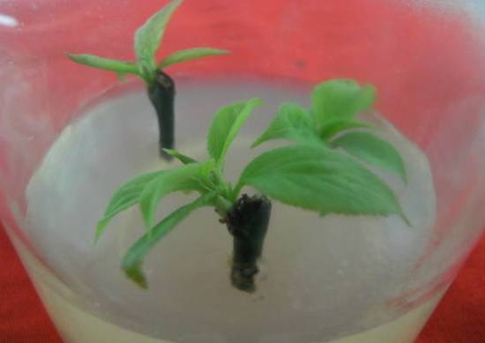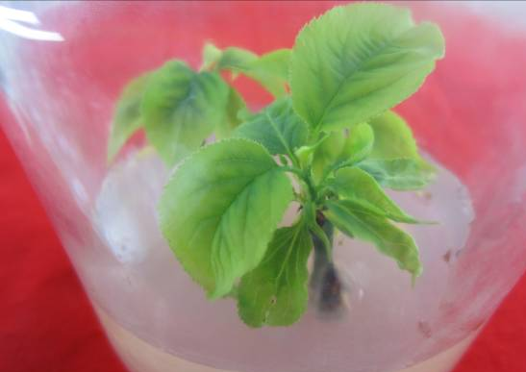
Fig4. Primary culture of ‘Wu Yuyu’ Fig5. Primary culture of ‘Xiao Yudie’
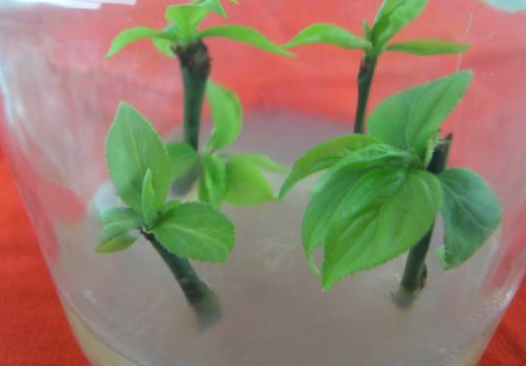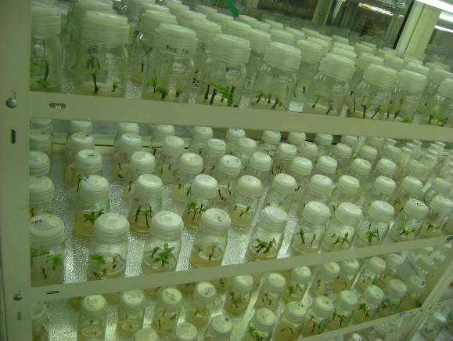
Fig6. Primary culture of ‘Xiao Lv’e’ Fig7.A large number of experimental materials
Callus proliferation
Most of the woody plants have a difficulty in tissue culture (Tan and Dai.1991), and because Prunus mume belongs to the typical recalcitrant plant, weak in recovery capability, tissue culture of Prunus mume faces challenges. In order to establish the rapid propagation system of Prunus mume, we need try to find and summarize several issues and then provide solutions after the observation of its primary culture. Cut the bud which is got from primary culture from the former explants, and then transfer them into secondary culture, so as to carry out the next experiment.
We choose WB、WPM、MS、1/2MS and 1/2WPM as basic medium, then add 1.0mg/L BA and 0.5mg/L NAA into them. The test results are shown in the following table.
Table9 The impact of different medium on proliferation rate of 3 cultivar groups
Medium | ‘Wu Yuyu’ -Zhusha cultivar group |  |  | ‘Xiao Yudie’ -Yudie cultivar group |  |  | ‘Xiao Lv’e’ -Lv’e cultivar group
Medium | Multiplicat-ion coefficient | Average bud length (cm) | Average bud height  (cm) | Multiplica-tion coefficient | Average bud length (cm) | Average bud height  (cm) | Multiplica-tion coefficient | Average bud length (cm) | Average bud height  (cm)
WB | 2.74±0.38^{bc} | 1.48±0.12ª | 2.39±0.13^{b} | 2.72±0.15^{b} | 0.48±0.10^{bc} | 0.93±0.18^{b} | 1.45±0.14^{c} | 0.68±0.13^{c} | 0.33±0.12^{c}
WPM | 3.37±0.17ª | 1.67±0.14ª | 3.23±0.17ª | 3.13±0.18ª | 0.73±0.14^{ab} | 0.89±0.15^{b} | 2.81±0.19ª | 1.17±0.16^{b} | 1.23±0.14ª
MS | 2.41±0.16^{c} | 1.01±0.19^{b} | 1.87±0.22^{c} | 2.71±0.19^{b} | 0.87±0.14ª | 0.72±0.14^{b} | 1.58±0.69^{c} | 0.63±0.13^{c} | 0.69±0.12^{b}
1/2WPM | 2.86±0.13^{b} | 1.17±0.14^{b} | 2.01±0.27^{c} | 2.21±0.22^{c} | 0.31±0.05^{c} | 0.67±0.14^{b} | 2.07±0.22^{b} | 0.77±0.15^{c} | 0.72±0.12^{b}
1/2MS | 2.59±0.11^{bc} | 1.13±0.12^{b} | 2.16±0.12^{bc} | 3.35±0.27ª | 0.95±0.14ª | 1.31±0.16ª | 2.73±0.18ª | 1.53±0.13ª | 0.89±0.12^{b}
As is shown in table9, the WPM mediun, which has the greatest impact on Zhusha cultivar group is WPM, has a significant difference from the other 4 mediums. While to Yudie and Lv’e cultivar group, the greatest impact medium is 1/2MS. WPM also have greatly influences on Yudie cultivar group, while 1/2MS and WPM have a significant difference from the remaining two mediums. The basic medium which has the lowest impact on Zhusha , Yudie and Lv’e cultivar group, respectively are MS、1/2WPM and WB. Taking the average bud length into account, the most suitable medium is WPM for Zhusha cultivar group(1.67±0.14cm), and 1/2MS of Yudie(0.95±0.14 cm) and Lv’e cultivar group(1.53±0.13 cm) .The basic medium which influence the average bud height most respectively are: WPM of Zhusha cultivar group(3.23±0.17 cm), 1/2MS of Yudie cultivar group(1.31±0.16 cm) and WPM of Lv’e cultivar group(1.23±0.14 cm) . To sum up，the most suitable secondary culture medium for Zhusha , Yudie and Lv’e cultivar group is: WPM , 1/2MS and WPM.
According to the above test, we take WPM＋BA1.0mg/L＋2,4-D1.0mg/L as basic medium, add 3 different densities of NAA、TDZ and AHC.According to the orthogonal design(L9(3⁴)) to set up the experiment. Orthogonal experiment design is shown in Table 10.
Table10 The combination of NAA、TDZ and AHC
Treatment number | NAA | TDZ | AHC | Treatment number | NAA | TDZ | AHC
1 | 1(0) | 1(0) | 1(0) | 6 | 2 | 3 | 1
2 | 1 | 2(0.2) | 2(100) | 7 | 3(1.0) | 1 | 3
3 | 1 | 3(0.4) | 3(200) | 8 | 3 | 2 | 1
4 | 2(0.5) | 1 | 2 | 9 | 3 | 3 | 2
5 | 2 | 2 | 3
After 30d of observation, we can receive the impact of different combination of NAA、TDZ and AHC on proliferation rate of three cultivar groups. The results are as shown in Table 11.
Table11 The impacts of different combination of hormone on proliferation rate of three cultivar groups
Cultivar | NAA | TDZ | AHC(mg/L) | Average number of bud | Average bud length(cm) | Growth state of bud
‘Wu Yuyu’ -Zhusha cultivar group | 0 | 0 | 0 | 2.01±0.18^{f} | 4.22±0.19^{f} | Bushy stunt and with  small leaves
‘Wu Yuyu’ -Zhusha cultivar group | 0 | 0.2 | 100 | 4.02±0.74ª | 7.31±0.18ª | Vigorous
‘Wu Yuyu’ -Zhusha cultivar group | 0 | 0.4 | 200 | 3.13±0.32^{cd} | 6.01±0.20^{bc} | Not weak enough
‘Wu Yuyu’ -Zhusha cultivar group | 0.5 | 0 | 100 | 3.43±0.21^{bc} | 5.89±0.12^{bc} | Not strong enough
‘Wu Yuyu’ -Zhusha cultivar group | 0.5 | 0.2 | 200 | 3.89±0.13^{ab} | 6.12±0.12^{b} | Not strong enough
‘Wu Yuyu’ -Zhusha cultivar group | 0.5 | 0.4 | 0 | 2.73±0.22de | 5.73±0.12^{cd} | Not strong enough
‘Wu Yuyu’ -Zhusha cultivar group | 1.0 | 0 | 200 | 2.44±0.14^{ef} | 4.98±0.12e | Bushy stunt and weak
‘Wu Yuyu’ -Zhusha cultivar group | 1.0 | 0.2 | 0 | 2.88±0.18^{cde} | 5.53±0.15^{d} | Not weak enough
‘Wu Yuyu’ -Zhusha cultivar group | 1.0 | 0.4 | 100 | 3.06±0.15^{cd} | 5.82±0.14^{c} | Not strong enough
‘Xiao Yudie’ -Yudie cultivar group | 0 | 0 | 0 | 0.09±0.06^{f} | 0.02±0.03e | Bushy stunt and with thin stems
‘Xiao Yudie’ -Yudie cultivar group | 0 | 0.2 | 100 | 1.95±0.20ª | 1.69±0.11^{b} | Weak
‘Xiao Yudie’ -Yudie cultivar group | 0 | 0.4 | 200 | 1.13±0.14^{b} | 0.69±0.14^{c} | Weak
‘Xiao Yudie’ -Yudie cultivar group | 0.5 | 0 | 100 | 0.52±0.08de | 0.27±0.15de | Not weak enough
‘Xiao Yudie’ -Yudie cultivar group | 0.5 | 0.2 | 200 | 2.01±0.16ª | 2.23±0.52ª | Vigorous
‘Xiao Yudie’ -Yudie cultivar group | 0.5 | 0.4 | 0 | 0.79±0.24^{cd} | 0.47±0.11^{cd} | Not strong enough
‘Xiao Yudie’ -Yudie cultivar group | 1.0 | 0 | 200 | 0.49±0.13e | 0.13±0.15de | Bushy stunt and with thin stems
‘Xiao Yudie’ -Yudie cultivar group | 1.0 | 0.2 | 0 | 1.01±0.12^{bc} | 0.39±0.17^{cde} | Weak
‘Xiao Yudie’ -Yudie cultivar group | 1.0 | 0.4 | 100 | 0.83±0.22^{c} | 0.43±0.17^{cd} | Not strong enough
‘Xiao Lv’e’ -Lv’e cultivar group | 0 | 0 | 0 | 2.21±0.21^{f} | 4.65±0.20e | Not strong enough
‘Xiao Lv’e’ -Lv’e cultivar group | 0 | 0.2 | 100 | 4.81±0.14ª | 6.65±0.11ª | Vigorous
‘Xiao Lv’e’ -Lv’e cultivar group | 0 | 0.4 | 200 | 3.56±0.41^{bc} | 5.61±0.18^{b} | Not strong enough
‘Xiao Lv’e’ -Lv’e cultivar group | 0.5 | 0 | 100 | 2.87±0.04e | 4.87±0.12de | Bushy stunt and with thin stems
‘Xiao Lv’e’ -Lv’e cultivar group | 0.5 | 0.2 | 200 | 5.03±0.11ª | 7.02±0.06ª | Vigorous
‘Xiao Lv’e’ -Lv’e cultivar group | 0.5 | 0.4 | 0 | 3.88±0.14^{b} | 5.77±0.16^{b} | Not strong enough
‘Xiao Lv’e’ -Lv’e cultivar group | 1.0 | 0 | 200 | 3.58±0.25^{bc} | 5.42±0.28^{bc} | Vigorous
‘Xiao Lv’e’ -Lv’e cultivar group | 1.0 | 0.2 | 0 | 3.13±0.18de | 5.13±0.26^{cd} | Thin stems and weak
‘Xiao Lv’e’ -Lv’e cultivar group | 1.0 | 0.4 | 100 | 3.44±0.19^{cd} | 5.02±0.40de | Thin stems and weak
It can be concluded from table11 that in the secondary culture of Zhusha and Yudie cultivar group, the combination which results in the largest number of buds and buds in greatest length is:TDZ0.2mg/L＋AHC100mg/L and NAA0.5mg/L＋TDZ0.2mg/L＋AHC100mg/L(4.02±0.74, 1.95±0.20 and 7.31±0.18cm, 2.23±0.52cm);While the suitable medium for Lv’e cultivar group is TDZ0.2mg/L＋AHC100mg/L and NAA0.5mg/L＋TDZ0.2mg/L＋AHC100mg/L,the difference between this two medium is not that significant. The medium with low appreciation rate of this three cultivar groups is the basic medium without any added hormone.
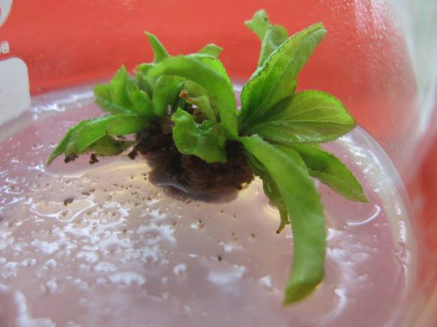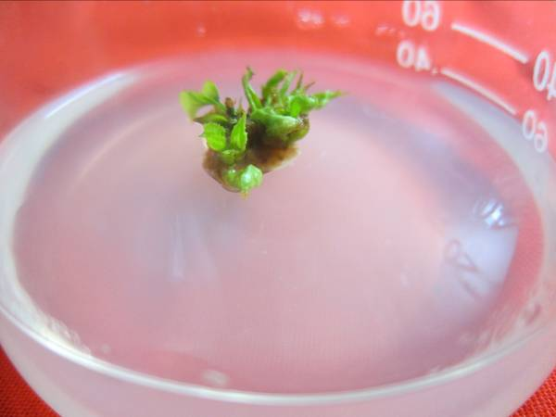
Fig8.Callus proliferation of ‘Wu Yuyu’ Fig9. Callus proliferation of ‘Xiao Yudie’
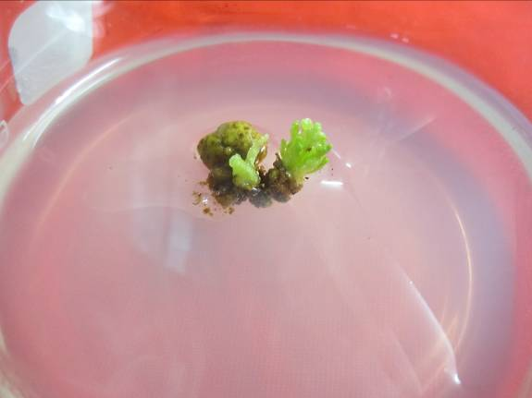 Fig10.Callus proliferation of ‘Xiao Lv’e’
Root induction
The proliferation seedlings are all dead after 30d, without any root. We need to do some further research to find out reasons.
Conclusion
It is very important for us to choose the appropriate explants. The reaction of different genotype, age even material parts of explants is different, may influence the reproductive effects and costs (Chen.1963). Choosing the perfect explants of three Prunus mume groups and the best disinfection time is the first step towards rapid propagation. On the basis of initiation culture, medium, hormone type and concentration was studied.
It can be seen from the first step that under the condition of three Hgcl₂ disinfection time, the germination rate are not that ideal, so the time should be divided into smaller time gap in the following research. For the callus proliferation of ‘Xiao Lv’e’, multiplication coefficient is so low that the combination of hormone is not so appropriate. Meanwhile, there are still so many problems resist in root induction that we need to do more experiment for far-researching.
References
C_{AO} L, L_{V} YM (2004) Research status and prospect of tissue culture on Prunus mume. The progressing of China‘s ornamental horticulture, Chinese Forestry Press (Beijing):163-171.
C_{AO} L, L_{V} YM, S_{UN} JP, D_{ONG} RB (2005) Research on primary culture of a few varieties of Prunus mume. The progressing of China‘s ornamental horticulture: 315-318.
C_{HAI} ML, S_{HEN} XD, L_{IN} BN (1988) The embryo culture and shoot regeneration of Prunus mume, Plant Physiology Communications 3:53-54.
C_{HEN}, JY (2010) The district of Prunus mume cultivar, Chinese Forestry Press.
C_{HEN} RD (2003) Research on hybridization and embryo culture of Prunus mume . Beijing Forestry University (Doctoral dissertation) , Beijing Forestry University Library.
C_{HEN} RD, S_{UN} WW (2007) Preliminary research of the opening primary culture on the variety of Prunus mume 'Dan Fenghou’. Journal of Beijing Forestry University ,29 (S l)：30-34.
C_{HEN} ZH (1963) Tissue culture and Application of Woody plant. Beijing: Higher Education Press: 13.
F_{U} EH (1993) In vitro rapid propagation method of Prunus mume. China Patent ZL90104477.6.
F_{U} EH, X_{U} HZ, W_{ANG} YL (1991) The study of micro-propagation of Prunus mume. Journal of Beijing Forestry University 9(3):275-280.
F_{U} EH , X_{U} HZ , W_{ANG} YL(1995) In vitro culture of the stem of Prunus mume ,Journal of Beijing Forestry University 17(S l)：76-78.
H_{ARADA} H, M_{URAI} Y (1996) Micro-propagation of Prunus mume , Plant Cell, Tissue and Organ Culture, 36(4): 265-267.
J_{IANG} ZP, L_{IANG} ZH, L_{IU} GL, Z_{HU} J (2004) The impaction of ZT and IAA on the proliferation and growth of Prunus mume. The progressing of China‘s ornamental horticulture 2:255-257.
L_{IU} QL, C_{HEN} QH, C_{HEN} JY (1999) Preliminary study on callus culture of Prunus mume .Journal of Beijing Forestry University, 21(2): 100-105.
O_{LAYA} P T, L_{ORENZO} B (2000) Different media requirements for micro-propagation of apricot cultivars. Plant Cell, Tissue and Organ Culture, 63(2): 133-141.
Q_{UOIRIN} M, L_{EPOIVER} P (1977) Improved media for in vitro culture of Prunus spp. Acta Horti, 78(6): 437-442.
T_{AN} WC ,D_{AI} CG (1991) Tissue culture of ornamental plant technology. Chinese Forestry Press.

*Corresponding author. Email: luyingmin@bjfu.edu.cn.

